Response Sheet to the Reviewer Comments

Final Paper Title | Ultra Lightweight Convolutional Neural Networks for Efficient Brain Tumor Classification in Resource Constrained Medical Environments
Paper ID | 157
Author(s) | Mahmoud Shamran Atheeb, Baraa Ismeal Farhan

Response to Reviewer (Reviewer 1)

Reviewer Comment | Write the Reviewer Comments here (Individual comment in each row)
Response (How you have addressed this comment?) | Describe here how you have addressed the comment? What changes you have made in your manuscript mention here.
Reviewer Comment 1 | We recommend adding a separate section titled Problem Statement that includes a systematic description of the scientific challenge, along with an identification of the limitations of current models.
Response | Thank you for this important suggestion. A dedicated Problem Statement section (Section 2) has been added to the revised manuscript. This section systematically describes four interconnected scientific challenges: (1) computational complexity of existing models such as U-Net (31M parameters), ResNet50 (25.5M), and VGG16 (138M); (2) generic feature extraction limitations; (3) single-scale processing inadequacy; and (4) static pooling inefficiency. The section concludes by articulating how the proposed architecture specifically addresses each of these challenges.
Reviewer Comment 2 | The methodology section needs more detail regarding the dataset preprocessing phase and the techniques used, for example, data normalization, data augmentation and data segmentation.
Response | We thank the reviewer for this observation. A dedicated subsection titled Data Preprocessing (Section 4.1) has been added to the revised manuscript. It details: (1) dataset integrity verification using MD5 hash checking confirming no duplicates across all 12,064 images of the Mendeley dataset version 4 (2025); (2) Image Normalization to [0,1] by dividing by 255; (3) Spatial Standardization to 128×128 pixels using bilinear interpolation; (4) Data Augmentation including random flips (p=0.5), rotations (±15°), brightness/contrast adjustments, and Gaussian noise, applied only to training data; (5) External Dataset Alignment confirming no rebalancing was applied.
Reviewer Comment 3 | Did the data obtained from Kaggle undergo any preprocessing, alignment or rebalancing of categories before evaluation?
Response | We appreciate this specific query. It is now explicitly addressed in Section 4.1. The Kaggle dataset underwent identical normalization and resizing as the primary dataset. No rebalancing or re-annotation of class labels was performed. The reported 99.24% accuracy therefore reflects genuine generalization under realistic domain-shift conditions with the original class distribution intact.
Reviewer Comment 4 | The author did not mention whether any limitations emerged in the work, such as data bias in the model or others.
Response | We thank the reviewer for highlighting this important gap. A dedicated Limitations paragraph has been added to the Discussion section acknowledging the following: (1) dataset-specific biases from publicly available MRI repositories; (2) sensitivity to acquisition protocol variations as reflected in Figshare performance (87.47%); (3) restriction to T1/T2-weighted sequences without multimodal support; (4) balanced class distributions not reflecting real clinical prevalence; (5) absence of tumor segmentation or grading capability; (6) patient-level data partitioning limitation due to lack of explicit patient identifiers in the Mendeley dataset, where an image-level 80/20 split was used and patient-level separation cannot be fully guaranteed; (7) Grad-CAM providing only qualitative explainability; and (8) clinical deployment requiring prospective multi-center trials and regulatory approval.
Reviewer Comment 5 | There is no performance comparison with the evaluation of radiologists, especially since the proposed work focuses on MRI imaging.
Response | We acknowledge this valid concern. A paragraph comparing model performance with radiologist benchmarks has been added to the Discussion. Published literature reports neuroradiologist inter-reader agreement of 70-88% with expert consensus around 85-90% for four-class differentiation. Our model achieves 99.22% on the primary dataset and above 98% on two external datasets, suggesting performance comparable to or exceeding expert radiologist accuracy. We clearly note the caveat that clinical radiological evaluation encompasses broader context beyond this automated classification, and recommend prospective clinical validation.
Reviewer Comment 6 | How does reducing the parameters affect the efficiency of the proposed model?
Response | This has been addressed with a dedicated paragraph in the Discussion section. The 80% parameter reduction (31M to 659K) produces: (1) lower overfitting risk; (2) faster convergence with stable gradient flow; (3) 47x reduction in model size (122 MB to 2.6 MB); (4) RAM reduction to 4.4 MB enabling edge deployment; and (5) 12 ms inference latency for real-time operation. The ablation study confirms efficiency is achieved without sacrificing accuracy, with intelligent pooling contributing +2.18% and multi-scale processing +2.12%.
Reviewer Comment 7
Response
Reviewer Comment 8
Response

Response to Reviewer (Reviewer 2)

Reviewer Comment | Write the Reviewer Comments here (Individual comment in each row)
Response (How you have addressed this comment?) | Describe here how you have addressed the comment? What changes you have made in your manuscript mention here.
Reviewer Comment 1
Response
Reviewer Comment 2
Response
Reviewer Comment 3
Response
Reviewer Comment 4
Response
Reviewer Comment 5
Response
Reviewer Comment 6
Response
Reviewer Comment 7
Response
Reviewer Comment 8
Response

Response to Reviewer (Reviewer 3)

Reviewer Comment | Write the Reviewer Comments here (Individual comment in each row)
Response (How you have addressed this comment?) | Describe here how you have addressed the comment? What changes you have made in your manuscript mention here.
Reviewer Comment 1
Response
Reviewer Comment 2
Response
Reviewer Comment 3
Response
Reviewer Comment 4
Response
Reviewer Comment 5
Response
Reviewer Comment 6
Response
Reviewer Comment 7
Response
Reviewer Comment 8
Response
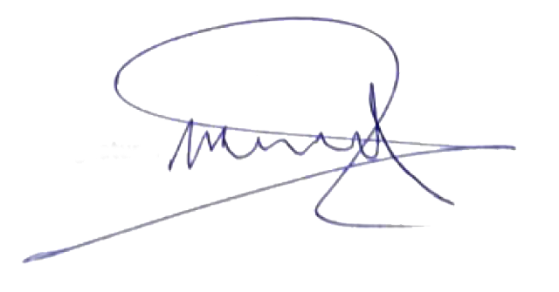

Put Signature here

Mahmoud Shamran Atheeb
Scanned Signature of the Corresponding Author

